Grant Agreement No: 654168
AIDA-2020
Advanced European Infrastructures for Detectors at Accelerators
Horizon 2020 Research Infrastructures project AIDA-2020

deliverable report

Very compact calorimeters

Deliverable: D14.4

Document identifier: | AIDA-2020_Deliverable_D14_4.docx
Due date of deliverable: | End of Month 57 (January 2020)
Justification for delay: | [if delays occurred]
Report release date: | dd/mm/yyyy
Work package: | WP14: Infrastructure for advanced calorimeters
Lead beneficiary: | AGH-UST
Document status: | Draft

Abstract:
The goal of this task was to build a very compact tungsten based calorimeter. For this aim a compact multi-layer sandwich type calorimeter with thin silicon active layers and tungsten absober layers needed to be built. The main components of the calorimeter are: thin (<1mm) sensor layers, precise thin tungsten absorber plates (<=3.5mm), compact readout boards with dedicated readout ASICs, and a flexible mechanical frame. The work performed for this deliverable is a demonstrator of such compact calorimeter together with the results of its validation from beamtests.

AIDA-2020 Consortium, 2020
For more information on AIDA-2020, its partners and contributors please see www.cern.ch/AIDA2020

The Advanced European Infrastructures for Detectors at Accelerators (AIDA-2020) project has received funding from the European Union’s Horizon 2020 Research and Innovation programme under Grant Agreement no. 654168. AIDA-2020 began in May 2015 and will run for 4 years.

Delivery Slip
 | Name | Partner | Date
Authored by | M. Idzik  W. Lohmann  A. Levy  H. Abramowicz | AGH-UST  DESY  TAU  TAU | 02/01/2020
Edited by | M. Idzik | AGH-UST | 02/01/2020
Reviewed by | I. Surname [Task coordinator]  I. Surname [WP coordinator]  I. Surname [Scientific coordinator] | [Short name]  [Short name]  [Short name] | dd/mm/yy
Approved by | I. Surname [Scientific coordinator]  Steering Committee |  | dd/mm/yy

TABLE OF CONTENTS
1. Introduction 4
2. Development of thin sensor layers 5
2. tungsten absorber plates 6
4. dedicated readout electronics 7
5. construction of calorimeter and beam test set-up 10
6. validation at beamtests 11
7. FUTURE PLANS / Conclusion / relation to other AIDA work 12
8. References 13
Annex: Glossary 14

Executive summary
A compact precise calorimeter is needed for luminosity measurement in forward region of future linear collider like ILC or CLIC. Witin the AIDA-2020 project a multi-layer demonstrator of such calorimeter was developed and tested on beams. The main components of the demonstrator are: thin sensor layers, precise thin absorber plates, and dedicated compact readout electronics.
The sensor layers were developed on the basis of existing 320 um thick silicon sensors. Thin carbon support was developed and thin Kapton fan-outs were designed and fabricated to connect electrically the sensor to the readout. In total, the complete sensor layer has 650 um thickness.
Precise thin tungsten absorber plates were developed and produced and the required flatness of the plates was verified by metrology measurements.
Dedicated ultra-low power 32-channel ASIC called FLAME was developed and produced as the core of the calorimeter readout system. FLAME contains an analog front-end and fast 10-bit ADC in each channel. The digitized data are serialized and transmitted off the chip by two (1 per 16 channels) fast data serializers&transmitters. To complete the readout system a compact PCB holding eight FLAME chips (to read 256 sensor channels) was designed and fabricated.
The demonstrater of a compact calorimeter was built and used in the beamtests to verify its performance. The measurement of the effective Moliere radius was carried out for energies between 1 and 5 GeV. The effective Moliere radius of 8.1 ± 0.1 mm was measured for 5 GeV energy, confirming excellent calorimeter performance.

Introduction

Forward calorimeters for future electron positron linear collider experiments have challenging requirements on a fast and high precision measurement of the luminosity [1], resulting in a stringent set of specifications for highly compact calorimeters. Two such calorimeters, LumiCal and BeamCal, are being considered for installation in the forward region of both International Linear Collider (ILC) [1] detectors, ILD and SiD, and also in the Compact Linear Collider (CLIC) detector [2]. The precise measurement of the integrated luminosity is provided by the LumiCal detector. BeamCal is designed for instant luminosity measurement and beam-tuning when included in a fast feedback system as well as for tagging beam particles scattered through low angles. Both detectors extend the capabilities of the experiments for physics studies in the high rapidity region.
Within the AIDA-2020 project a demonstrater of a very compact tungsten based calorimeter was developed and verified in beamtests to check its performance in experimental conditions. The main developed components of the calorimeter are: thin (<1mm) sensor layers, precise thin (<=3.5mm) tungsten plates, and compact readout boards with dedicated readout ASICs. The performance of this calorimeter, in particular its compactness, reflected by small Moliere radius, was verified on the beam at different development stages. It was measured that with the developed thin detector planes the effective Moliere radius could be largely reduced from 24 mm down to 8.1 mm.

Development of thin sensor layers

The design of a LumiCal sensor was optimised in simulations to provide the required resolution of the polar angle reconstruction. A picture of a sensor is shown in Fig. 1. The sensor is made of a 320 μm thick high resistivity n-type silicon wafer. It has the shape of a sector of a 30◦ angle, with inner and outer radii of the sensitive area of 80 mm and 195.2 mm, respectively. It comprises four sectors with 64 p-type pads of 1.8 mm pitch.
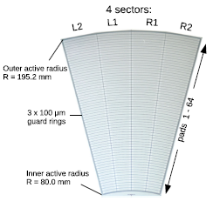

Fig. 1 A LumiCal silicon sensor

The properties of the sensor were studied in the lab and beam tests. Results of beam tests and more details about the sensor can be found in Refs. [1]. The first prototype of a LumiCal detector plane, which has been successfully used in a multi-layer configuration [1,2], had a thickness of about 4mm and only 32 pads were connected to the readout electronics.

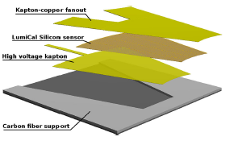

Fig. 2 Detector plane assemby.Total thickness is 650um

For the construction of a sub-millimetre detector plane the same silicon sensor is used. The bias voltage is supplied to the n-side of the sensor by a 70 μm flexible Kapton–copper foil, glued to the sensor with a conductive glue. The 256 pads of the sensor are connected to the front-end electronics using a fan-out made of 120 μm thick flexibleKapton foil with copper traces. The inner guard ring is grounded. Ultrasonic wire bonding was used to connect conductive traces on the fanout to the sensor pads. A support structure, made of carbon fibre composite with a thickness of 100 μm in the sensor gluing area, provides mechanical stability for the detector plane. Special fixtures were designed and produced to ensure the necessary thickness and uniformity of three glue layers between different components of the detector plane all over the area of the sensor. A sketch of the structure of the detector plane is shown in Fig. 2 and a photo of a completed plane in Fig. 3.

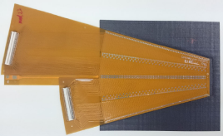

Fig. 3 A thin detector plane. The black part is the carbon fibre support, the silicon sensor is covered by the Kapton fan-out

The ultrasonic wire bonding proved to provide good electrical performance, but for a detector plane thinner than 1mm, the wire loops, which are typically 100–200 μm high, cause a serious problem when the plane needs to be installed in a 1 mm gap between absorber plates. The parameters of the bonding machine were studied and tuned to make the loop as low as possible and technically acceptable. The sampling based measurements, which were done using a con-focal laser scanning microscope, show that the loop height is in the range from 50 to 100 μm.

Tungsten absorber plates

In the first multi-layer calorimeter beamtest [1] the LumiCal prototype comprised a mechanical structure of eight tungsten absorber planes interspersed with four fully assembled sensor planes at different positions in between. The tungsten absorber plates were 3.5 mm thick and mounted in permaglass frames. The tungsten absorber thickness uniformity was extensively tested. The maximum differences in the flatness on front/back side do not exceed the required ±10/±50 μm.
Within AIDA-2020 new 25 tungsten plates of the size 140mm x140mm x 3.5mm and of the precision similar to previous ones were developed, fabricated, and verified (by the CERN metrology group). Example tungsten plate is shown in Fig. 4. In total more than 30 precise tungsten plates were produced.

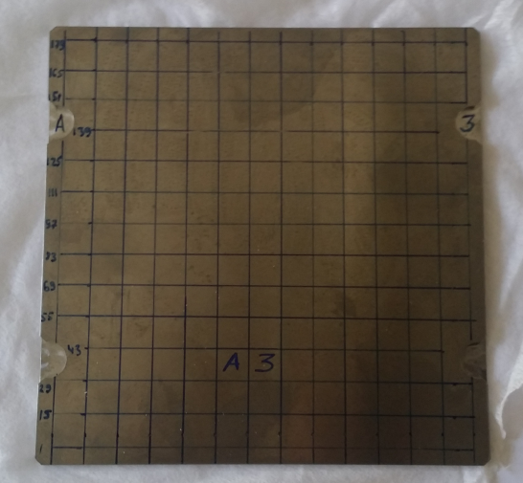

Fig. 4 A 3.5 mm thick tungsten plate

Dedicated Readout electronics

The existing readout [1,2] was limited in the number of channels allowing to build only small (32 readout channels) prototypes of detector modules. For very compact calorimeter a larger ultra-low power, SoC type (all functionalities on chip) readout ASIC is needed. The development of such an ASIC, called FLAME (FcaL Asic for Multiplane rEadout) has been done in CMOS 130 nm process [3].
The block diagram of FLAME is shown in Fig. 5. FLAME is based on the same architecture as the previous readout, with an analogue front-end and a 10-bit ADC [4] in each channel. It is developed in a smaller feature-size TSMC 130 nm CMOS technology. This choice allows to obtain a large reduction of the power consumption and much better radiation hardness. A System on Chip (SoC) architecture was chosen, comprising all functionality (analogue front-end, ADC, data serialisation and transmission) in one ASIC. This will simplify the architecture of the overall readout system, minimising the number of its components. To make a compact readout able to process signals from all sensor channels the number of channels in the ASIC was increased from 8 (in previous ASIC) to 32 in the FLAME. It was decided as a compromise between between the compactness of the readout and the cost of the FLAME ASIC. In this way, using a readout board with eight 32-channel ASICs one can build a detector module that reads the whole LumiCal sensor tile, containing 256 channels. The FLAME chip is built of two identical 16-channel blocks. The data from each block is sent out by a very fast (5.2 Gbps) serialiser and a serial data transmission block. The output data are coded and formatted and can be received directly by fast FPGA links.

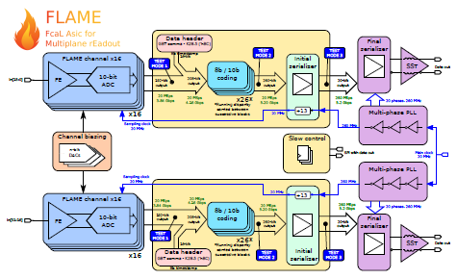

Fig. 5 Block diagram of the FLAME readout ASIC

The development of FLAME was done in two stages. In the first stage prototypes of two main blocks, i.e. an 8-channel ASIC containing front-end plus ADC in each channel and a serialiser and data transmission ASIC, were developed. The design and tests of these blocks are described in AIDA-2020 Milestone Report [5]. In the second stage the complete FLAME ASIC, comprising 32 front-end channels and two fast data transmission links, was developed. By now 80 ASICs were produced, which is enough to instrument up to 10 readout planes The photograph of the FLAME ASIC bonded to the test PCB board is shown in Fig 6.

Fig. 6 Photograph of the FLAME readout ASIC bonded to test PCB
The functionality of FLAME was positively verified during laboratory tests. Example laboratory measurement of a test pulse together with CR-RC fit is shown in Fig. 7. Such result confirms the expected pulse shape behavior but more importantly, it shows that the whole signal processing chain, including data serialization and fast transmission, works correctly.
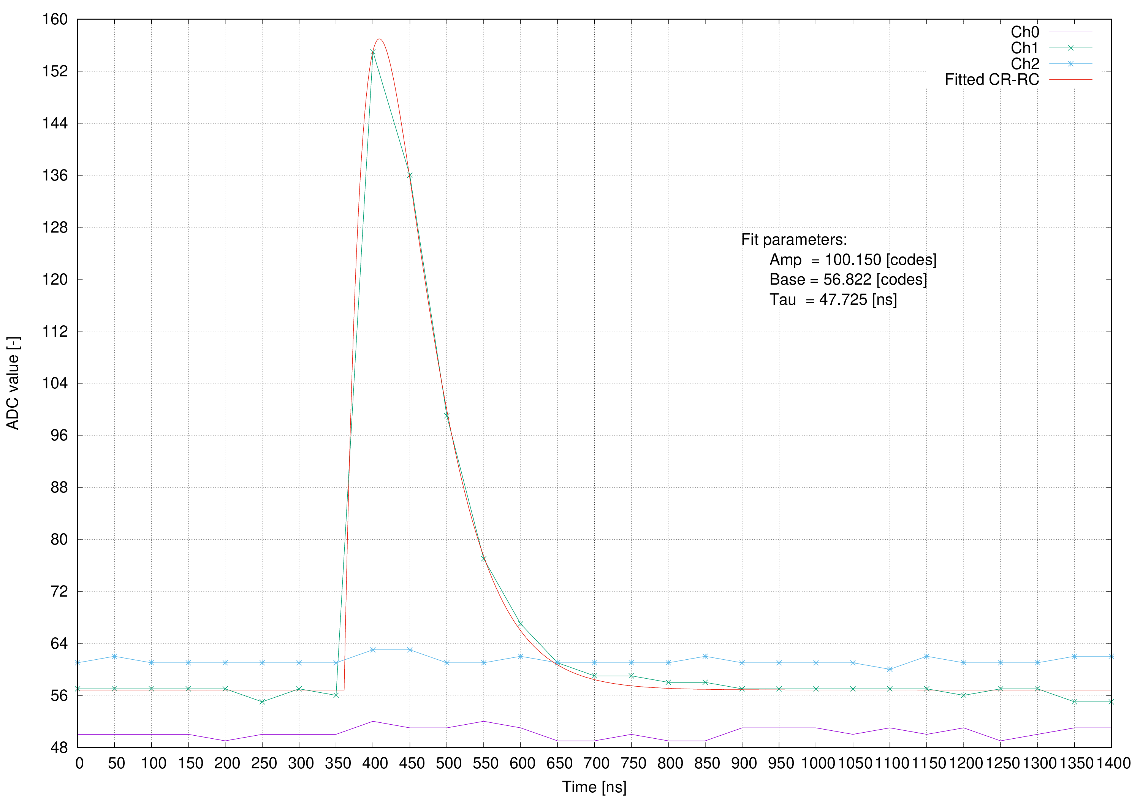

Fig. 7 Example test pulse on channel 1 together with CR-RC fit. Channels 0 and 2 are shown to check the crosstalk

After the succesfull verification of FLAME performance a compact PCB board allowing for the readout of 256-channel sensor tile was designed and fabricated. The photograph of the PCB is shown in Fig. 8. At the top two 128-channel connectors for the sensor Kapton fan-outs should be mounted. Middle part will be populated by eigh FLAME ASICs.
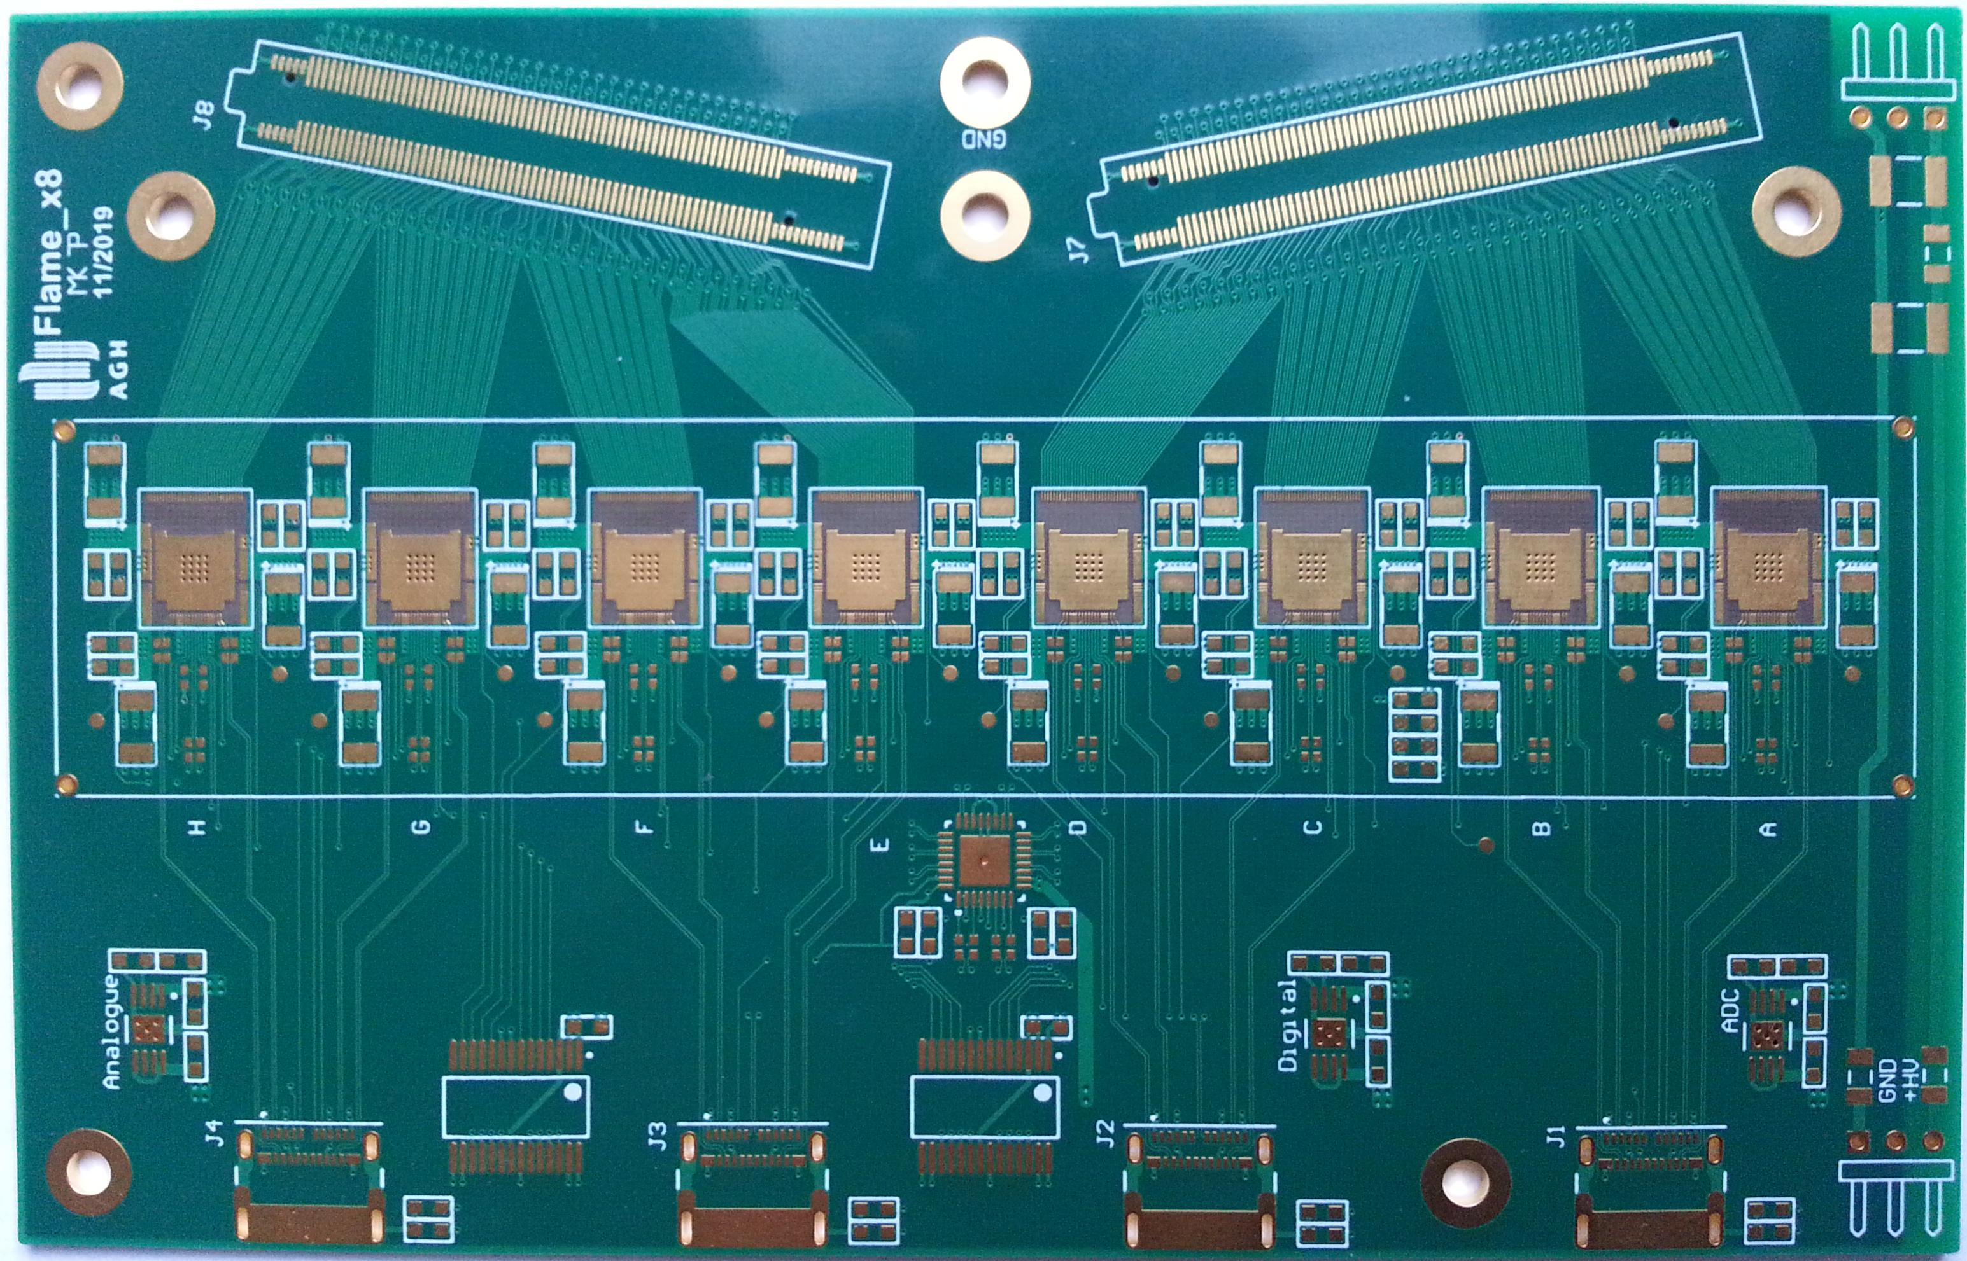

Fig. 8 Photograph of compact PCB for 256-channel sensor readout

Presently the whole FLAME based readout system, including FLAME chips, compact readout PCBs and data acquisition system (DAQ) is being assembled in order to be used in the next beamtest.

Construction of calorimeter and beamtest set-up

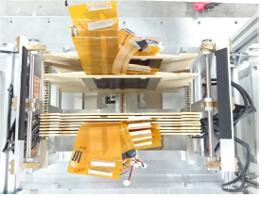

Fig. 9 Top view of assembled calorimeter

A compact calorimeter demonstrator was built using the discussed above key components. The thin detector planes were installed in the 1-mm gap between the tungsten absorber layers, inside previously developed [1] precise mechanical frame, as seen in Fig. 9. Each tungsten absorber layer is on average 3.5 mm thick and roughly one radiation length (1 X0). As shown in Fig. 10, the first calorimeter sensor layer was placed after 3 absorber layers, and the rest followed after each additional absorber layer. The last sensor layer was placed after 8 absorber layers with a total thickness of 7.7 X0 since, as noted in [1], the absorber layers are not pure tungsten.
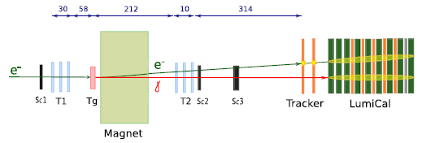

Fig. 10 Geometry of the beamtest setup

The detector planes were tested in two beam test campaigns in 2015 and 2016 at the DESY-II Synchrotron using electrons with energies between 1 and 5 GeV. Since at that time the multi-channel version of the FLAME-based dedicated front-end electronics was still under development, the APV25 front-end board [6], used by the silicon strip detector of the CMS experiment, was chosen as a temporary solution for first beamtests. It has 128 channels, hence two boards were used to read the whole sensor layer.

Validation at beamtests

The testbeam campaigns were done to study the performance of the compact calorimeter demonstrator and to test the concept of tracking detectors in front of the calorimeter as a tool for electron and photon identification. In order to analyse the electromagnetic shower development, the deposited energy in each sensor plane was obtained. The measurement results from the test beam were compared with prediction of GEANT4 Monte Carlo simulations where the experimental setup was implemented.
The measurement of the effective Moliere radius was carried out for energies between 1 and 5 GeV following the steps described in Ref. [7]. The transverse shower profile at 1, 3 and 5 GeV beam energy, as a function of the distance from the core, in units of pad dimensions (1.8 mm) for the data and fit function, is presented in Fig. 11 [7]. The fitted function reproduces the experimental transverse shower profile with an accuracy better than 5%.The average deposited energies are lower at lower beam energies, and the distributions are wider, resulting in a larger value of the effective Moliere radius, an effect which can be explained with different fractions of shower leakage. The effective Moliere radius is 8.1 ± 0.1 mm for 5 GeV energy, a value well reproduced by the MC simulation 8.4 ± 0.1 mm. The data are well described by the results of simulations.
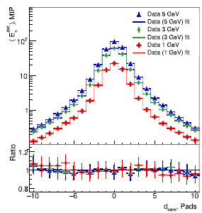

Fig. 11 Average transverse shower profile as a function of d_{core} in units of pads, for different beam energies. The lower portion of the figure displays the ratio between data and fit functions.

FUTURE PLANS / Conclusion / relation to other AIDA-2020 work
The highly compact multi-layer calorimeter demonstrator was built within AIDA-2020 project and tested at the DESY II Synchrotron with an electron beam with energies between 1 and 5 GeV. Using new technology and expertise at each construction step, compact detector layers with less than 1mm thickness, together with precise thin tungsten plates were developed. During the performed beamtest a temporary readout system, based on APV ASIC was used, since the dedicated FLAME ASIC readout system had been developed in parallel. Measurements of transverse and longitudinal shower shapes were performed on the beam and compared to a detailed MC simulation, and were found to be in good agreement with expectations. The effective Moliere radius was determined to be 8.1 ± 0.1 mm. This value is close to the technological limit.

The ultra-low power, dedicated SoC type 32-channel front-end ASIC called FLAME was developed and produced as a core of the compact calorimeter readout system. A compact PCB board holding eight FLAME ASICs was also designed and fabricated. In the closest future a new beamtest of compact calorimeter demonstrator, inculing the final FLAME based readout sytem, will be performed.

References

[1] H. Abramowicz, et al., Measurement of shower development and its Molière radius with a four-plane LumiCal test set-up, The European Physical Journal C 78 (2018) 135
[2] A. Abusleme, et al., Detector Technologies for CLIC, CERN Yellow Report CERN-2019-001, http://arxiv.org/abs/arXiv:1905.02520
[3] M. Idzik, et al., FLAME – readout ASIC for luminosity calorimeter at future linear collider, Topical Workshop on Electronics dor Particle Physics, TWEPP 2018, 17-21 September 2018, KU Leuven, Antwerpen, Belgium, https://indico.cern.ch/event/697988/contributions/3055910/attachments/1718342/2772974/idzik_TWEPP2018_FLAME.pdf
[4] J. Moron, et al., Development of ultra-low power, rad-hard SAR ADCs in 130 nm CMOS technologies, Topical Workshop on Electronics dor Particle Physics, TWEPP 2018, 17-21 September 2018, KU Leuven, Antwerpen, Belgium, https://indico.cern.ch/event/697988/contributions/3055906/attachments/1718216/2772757/moron_Twepp_ADC_2018_09.pdf
[5] M. Idzik, Design and test of ASICs and readout board prototype for the test infrastructure, AIDA-2020 Milestone Report AIDA-2020-MS57 (2017)
[6] M.J. French, et al., Design and results from the APV25, a deep sub-micron CMOS front-end chip for the CMS tracker, Nucl. Instr. Methods A 466, 359 (2001)
[7] H. Abramowicz, et al., Performance and Molière radius measurements using a compact prototype of LumiCal in an electron test beam, The European Physical Journal C 79 (2019) 579

Annex: Glossary

Acronym | Definition
ASIC | Application Specific Integrated Circuit
LumiCal | Luminosity Calorimeter
BeamCal | Beam Monitor Caloruimeter
PCB | Printed Circuit Board

