Grant Agreement No: 654168
AIDA-2020
Advanced European Infrastructures for Detectors at Accelerators
Horizon 2020 Research Infrastructures project AIDA-2020

deliverable report

Very compact calorimeters

Deliverable: D14.4

Document identifier: | AIDA-2020_Deliverable_D14_4_v4.docx
Due date of deliverable: | End of Month 57 (January 2020)
Justification for delay: | [if delays occurred]
Report release date: | dd/mm/yyyy
Work package: | WP14: Infrastructure for advanced calorimeters
Lead beneficiary: | AGH-UST
Document status: | Draft

Abstract:
The goal of this task was to build infrastructure of a very compact silicon-tungsten sandwich calorimeter. The infrastructure contains a flexible mechanical frame, very thin precise silicon planes, highly planar tungsten absorber plates, and compact readout boards equipped with dedicated readout ASICs using CMOS 130 nm TSMC technology. The thickness of a silicon detector plane is below the gap of one mm between tungsten absorber plates of 3.5 mm thickness. To build the infrastructure, the mechanical frame had to be designed and manufactured, silicon detector planes, tungsten absorber plates and dedicated readout ASICs needed to be developed and produced. A partially instrumented version was investigated in a beam-test. Results on the performance, including a measurement of the Moliere radius, approaching the smallest possible value, are published in EPJ C. Recently tests have been started of a full device in an electron beam. Results are under work. A spin-off of this deliverable is the use of part of the ASICs in the electromagnetic calorimeter and timing detector of the upgraded CMS experiment.

AIDA-2020 Consortium, 2020
For more information on AIDA-2020, its partners and contributors please see www.cern.ch/AIDA2020

The Advanced European Infrastructures for Detectors at Accelerators (AIDA-2020) project has received funding from the European Union’s Horizon 2020 Research and Innovation programme under Grant Agreement no. 654168. AIDA-2020 began in May 2015 and will run for 4 years.

Delivery Slip
 | Name | Partner | Date
Authored by | M. Idzik  W. Lohmann  H. Abramowicz  A. Levy | AGH-UST  DESY  TAU  TAU | 02/01/2020
Edited by | M. Idzik | AGH-UST | 02/01/2020
Reviewed by
Approved by | Steering Committee

TABLE OF CONTENTS
1. Introduction 4
2. Development of thin sensor layers 5
2. tungsten absorber plates 6
4. dedicated readout electronics 7
5. construction of calorimeter and beam-test set-up 10
6. validation at beam-tests 11
7. FUTURE PLANS / Conclusion / relation to other AIDA work 13
8. References 14
Annex: Glossary 15

Executive summary
A compact and highly precise electromagnetic calorimeter in the very forward region will be needed for the measurement of the luminosity in future linear collider detectors, e.g. at ILC or CLIC. Within the AIDA-2020 project a multi-layer demonstrator of such a calorimeter was developed, built and tested in beams. The main components of the demonstrator are: a flexible mechanical frame for precise positioning of detector planes and absorber plates, very thin active detector planes, tungsten absorber plates of high planarity, and dedicated compact readout electronics.
The detector planes were built using existing 320 µm thick silicon pad sensors. Thin carbon supports were developed and thin Kapton fan-outs were designed and fabricated to connect electrically the sensor pads to the readout. In total, the complete detector plane has a thickness of 650 µm.
Tungsten absorber plates of 3.5 mm thickness were developed and produced and the required flatness of 50 µm was verified by metrology measurements.
A dedicated ultra-low power 32-channel ASIC, called FLAME, was developed and produced as the core of the calorimeter readout system. FLAME contains an analogue front-end and a fast 10-bit ADC in each channel, consuming in total about 2 mW/channel. The digitized data from each chip is fed into two fast data serializers&transmitters. To complete the readout system a compact PCB holding eight FLAME chips, controlled by an FPGA, was designed and fabricated.
The demonstrator of a very compact calorimeter was built and operated in beam-tests at different stages of the construction to measure its performance. The longitudinal and transverse shower profile was compared to Monte Carlo simulations. Very good agreement was found. The effective Moliere radius was measured for electrons with energies between 1 and 5 GeV. At 5 GeV electron energy, an effective Moliere radius of 8.1 ± 0.3 mm was measured compared to 8.4 ± 0.1 mm obtained from simulations.

Introduction

Forward calorimeters for future electron-positron collider experiments have to match challenging requirements on a fast and high precision measurement of the luminosity [1], resulting in a stringent set of specifications of energy, time and shower position resolutions and shower reconstruction efficiency for electrons and photons at low polar angles. These specifications translate in high mechanical precision, high compactness, and a corresponding readout architecture of electromagnetic calorimeters. Two such calorimeters, LumiCal and BeamCal, are being designed for installation in the forward region of both International Linear Collider (ILC) [2] detectors, ILD and SiD, and also in the Compact Linear Collider (CLIC) detector [3]. The precise measurement of the integrated luminosity is provided by LumiCal. BeamCal is used for instant luminosity measurement and beam-tuning when included in a fast feedback system as well as for tagging beam particles scattered through low angles. Both detectors extend the coverage of the experiments to low polar angles, being important for other physics studies.
Within the AIDA-2020 project a demonstrator of a very compact electromagnetic calorimeter was developed matching the requirements on mechanical precision, compactness and readout bandwidth
mentioned above. The main characteristics of the demonstrator are: active detector planes of 650 µm thickness, tungsten absorber plates of 3.5 mm thickness with a flatness of better than 50 µm, and compact readout boards with dedicated readout ASICs in 130 nm TSMC technology. The performance of this calorimeter was measured in several steps of the construction and found in agreement with the expectations from Monte Carlo simulations. In particular, the compactness, reflected by an effective Moliere radius of 8.1 ± 0.3 mm, was pushed near the technological limit.

Development of thin DETECTOR PLANES

The design of LumiCal sensors was optimised using simulations to provide the required resolution of the polar angle reconstruction [1]. A picture of a sensor is shown in Fig. 1. The sensor is made of a 320 μm thick high resistivity n-type silicon wafer. It has the shape of a sector of 30◦ angle, with inner and outer radii of the sensitive area of 80 mm and 195.2 mm, respectively. It comprises four sub-sectors with 64 p-type radial pads of 1.8 mm pitch.

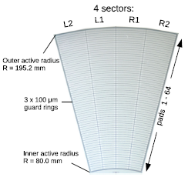

Fig. 1 A LumiCal silicon sensor

Properties of the sensors were studied in the laboratory and in beam-tests. Results and more details about the sensor can be found in Ref. [4]. First prototypes of LumiCal detector planes, successfully used in a multi-layer configuration [5], had a thickness of about 4mm due to the sensor assembly on thick PCB.

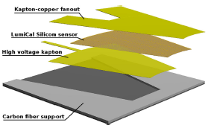

Fig. 2 Detector plane assemby.Total thickness is 650µm

For the construction of a sub-millimetre detector plane the same silicon sensor is used. The bias voltage is supplied to the n-side of the sensor by a 70 μm flexible Kapton–copper foil, glued to the sensor with a conductive glue. The 256 pads of the sensor are connected to the front-end electronics using a fan-out made of 120 μm thick flexible Kapton foil with copper traces. The inner guard ring is grounded. Ultrasonic wire bonding was used to connect conductive traces on the fan-out to the sensor pads. A support structure, made of carbon fibre composite with a thickness of 100 μm, provides mechanical stability for the detector plane. Special jigs were designed and produced to precisely align all components and ensure the necessary thickness and uniformity of three adhesive layers between different components of the detector plane all over the area of the sensor. A sketch of the structure of the detector plane is shown in Fig. 2 and a photo of a completed plane in Fig. 3.

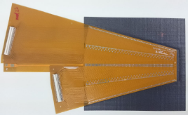

Fig. 3 A detector plane. The black part is the carbon fibre support, the silicon sensor is covered by the Kapton fan-out

The ultrasonic wire bonding proved to provide very good electrical performance, but for a detector plane thinner than 1mm, the wire loops, which are typically 100–200 μm high, caused a serious problem when the plane needs to be installed in a 1 mm gap between absorber plates. The parameters of the bonding machine were tuned to make the wire loop as low as possible and technically feasible. The sampling based measurements, which were done using a con-focal laser scanning microscope, showed that the loop height is in the range from 50 to 100 μm.

Tungsten absorber plates

Within the AIDA-2020 project, 25 tungsten plates of the size 140mm x140mm x 3.5mm were produced. The flatness has been measured by our partners from JINR with a ZEISS 3D ECLIPSE, and found to be, after a second machining step, to be within the required tolerances of ±10/±50 μm. These measurements were verified by the CERN metrology group. An example of a tungsten plate is shown in Fig. 4. Together with previously produced ones, more than 30 precise tungsten plates are now available.

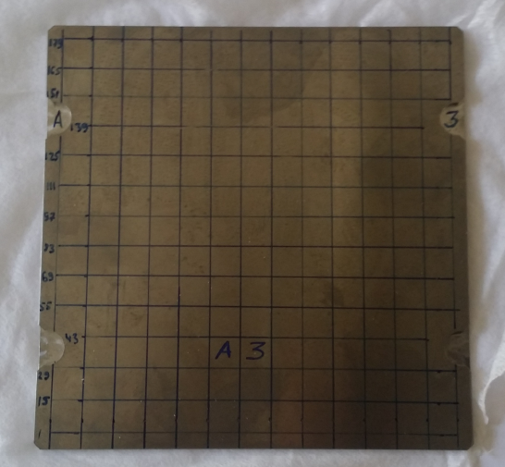

Fig. 4 A 3.5 mm thick tungsten absorber plate

Dedicated Readout electronics

The initial readout system described in Ref. [4] was limited in the number of channels. Therfore the detector was read out only partially. For a very compact calorimeter a larger ultra-low power, System on Chip (SoC) type readout ASIC is needed. The development of such an ASIC, called FLAME (FcaL Asic for Multiplane rEadout) has been done in CMOS 130 nm technology [6].
The block diagram of FLAME is shown in Fig. 5. FLAME is based on the same architecture as the previous 350 nm ASIC, with an analogue front-end and a 10-bit ADC [7] in each channel. It is developed in TSMC 130 nm CMOS technology. This choice allows to obtain a large reduction of the power consumption and much better radiation hardness. A SoC architecture was chosen, comprising all functionality (analogue front-end, ADC, data serialisation and transmission) in one ASIC. This will simplify the architecture of the overall readout system and minimise the number of its components. The number of channels in the ASIC was increased from 8 in the previous ASIC to 32 in FLAME. It was decided as a compromise between the compactness of the readout and the cost of the FLAME ASIC. Using a readout board with eight 32-channel ASICs the whole LumiCal sensor tile, containing 256 channels, is read out. The FLAME chip is built of two identical 16-channel blocks. The data from each block is sent out by a 5.2 Gbps serialiser and a serial data transmission block. The output data are coded and formatted and can be received directly by fast FPGA links.

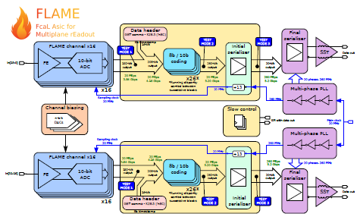

Fig. 5 Block diagram of the FLAME readout ASIC
The development of FLAME was done in two stages. In the first stage prototypes of two main blocks, i.e. an 8-channel ASIC containing front-end plus ADC in each channel and a serialiser and data transmission ASIC, were developed. The design and tests of these blocks are described in AIDA-2020 Milestone Report [8]. In the second stage the complete FLAME ASIC, comprising 32 front-end channels and two fast data transmission links, was developed. By now 80 ASICs were produced, which is enough to instrument up to 10 readout planes A picture of the FLAME ASIC bonded to the test PCB board is shown in Fig 6.

Fig. 6 Photograph of the FLAME readout ASIC bonded to test PCB
The functionality of FLAME was successfully validated during laboratory tests. As an example a test pulse together with CR-RC fit is shown in Fig. 7. It confirms the expected pulse shape behaviour but more importantly, shows that the entire signal processing chain, including data serialization and fast transmission, works correctly.
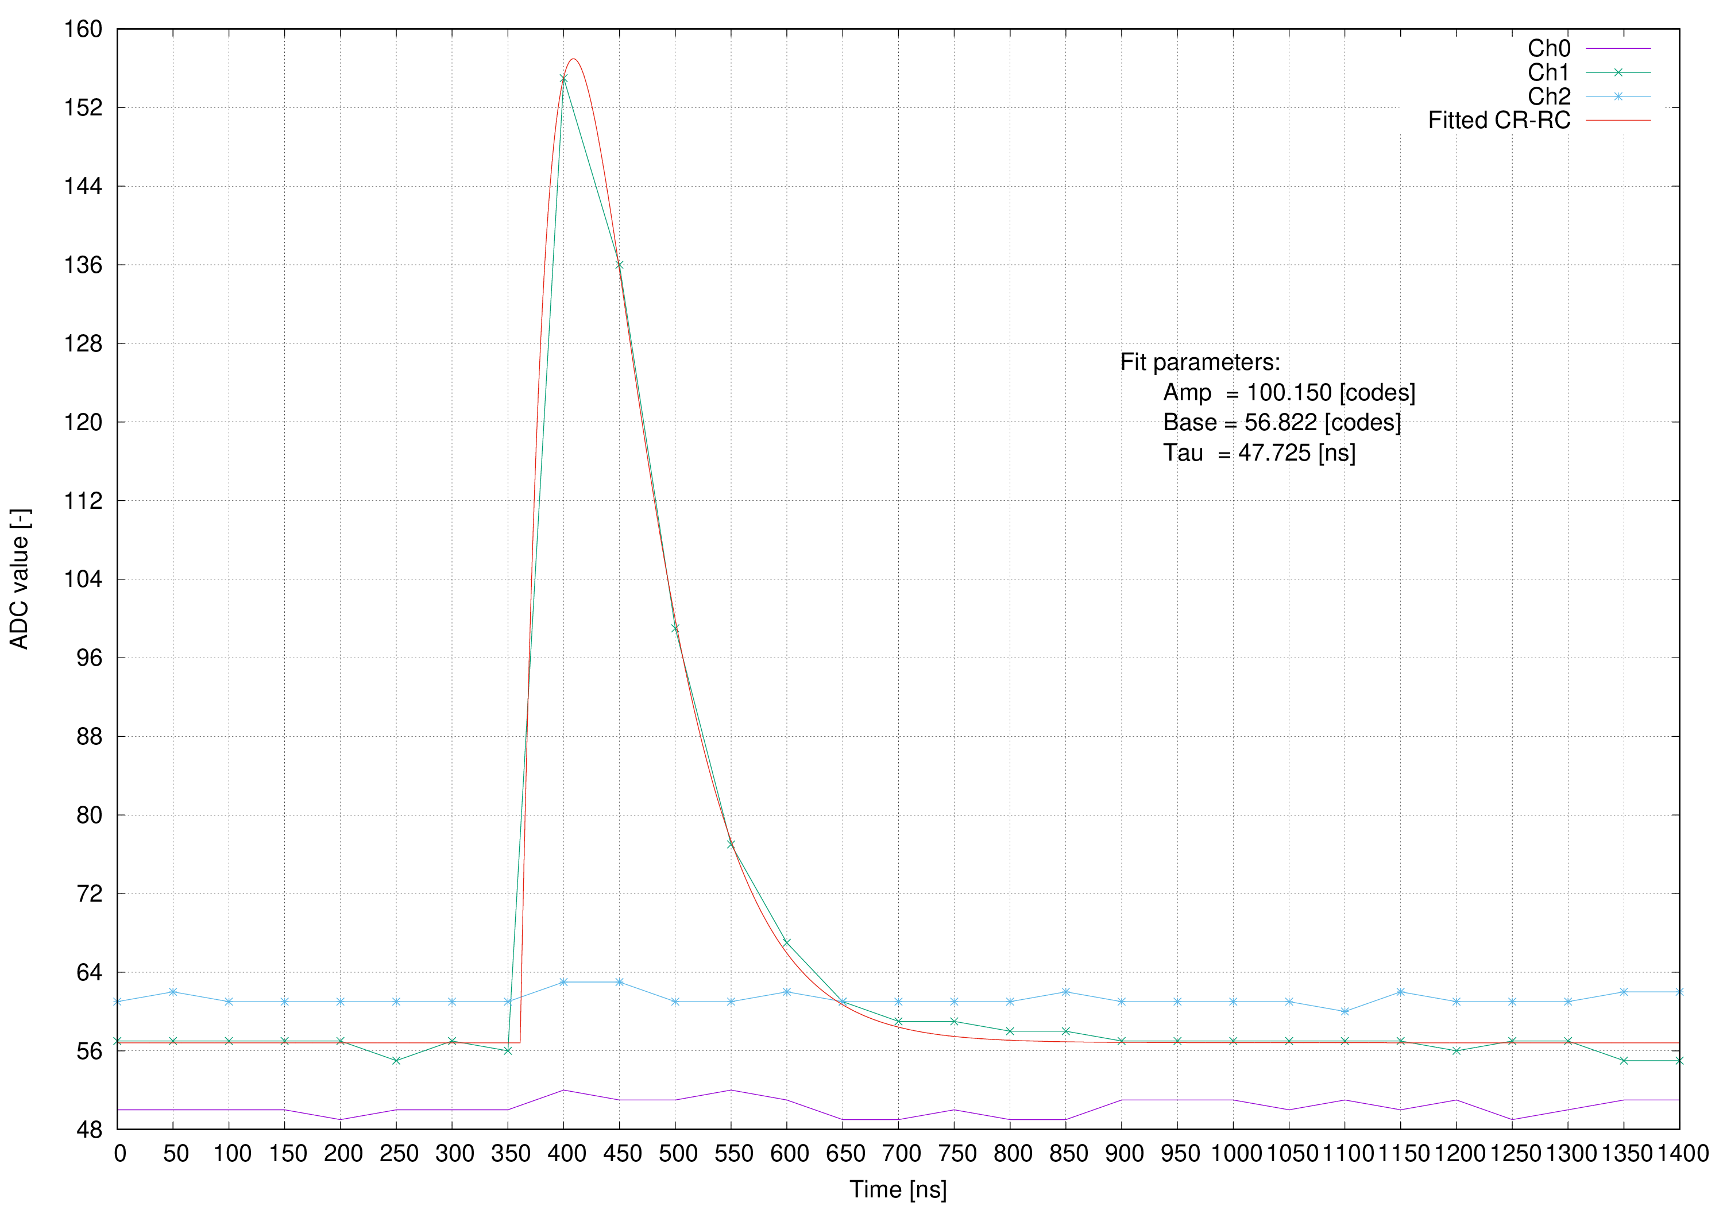

Fig. 7 Example test pulse on channel 1 together with CR-RC fit. Channels 0 and 2 are shown to check the crosstalk

After the successful verification of the FLAME performance a compact PCB board, with the thickness similar to silicon-tungsten sandwich plane, allowing for the readout of the 256-channel sensor tile was designed and fabricated. The photograph of the PCB is shown in Fig. 8. At the top two 128-channel connectors for the Kapton fan-outs of the detector plane are visible. The middle part will be equipped with eight FLAME ASICs.
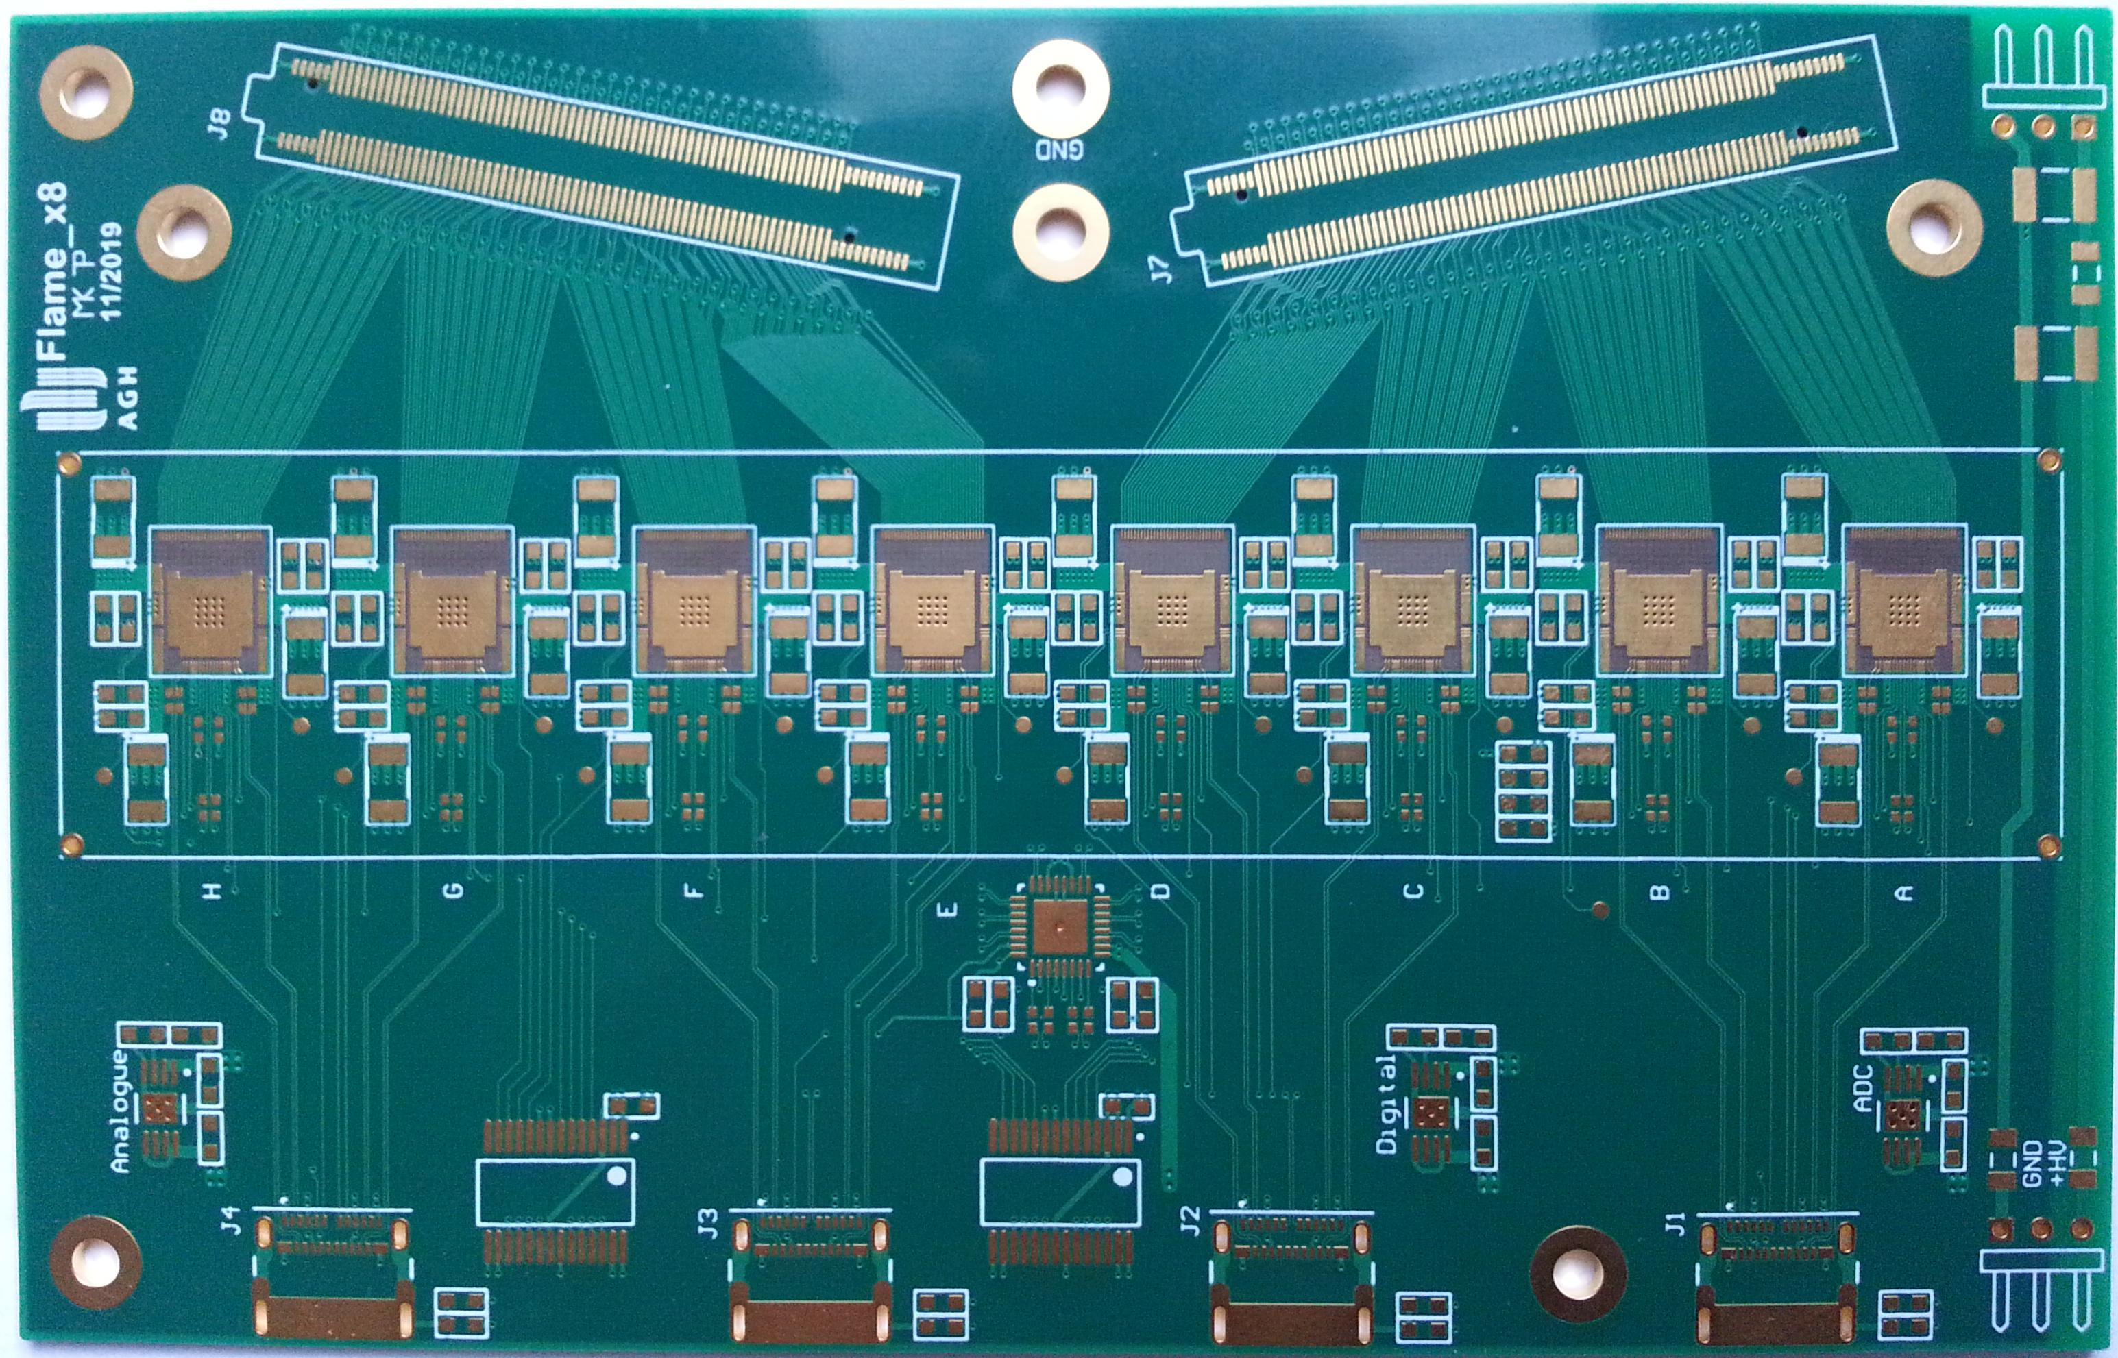

Fig. 8 Photograph of compact PCB for 256-channel sensor readout

Currently the whole FLAME based readout system, including FLAME chips, compact readout PCBs and data acquisition system (DAQ) is being assembled in order to be used in the next beam-test.

Construction of calorimeter and beam-test set-up
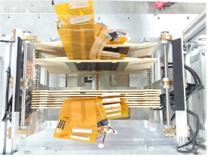

Fig. 9 Top view of part of the assembled calorimeter
A compact calorimeter demonstrator was built using the discussed above key components. The thin detector planes were installed in the 1-mm gap between the tungsten absorber plates. Both detector planes and absorber plates are precisely positioned in the previously developed [5] precise mechanical frame, also seen in Fig. 9.
A scheme of an intermediate beam-test in 2016 is shown in Fig. 10. The first detector plane was placed after 3 absorber plates, and the rest followed after each additional absorber plate. The last detector plane was placed after 8 absorber plates with a total thickness of 7.7 X0.
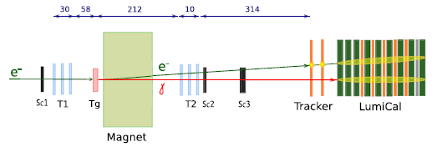

Fig. 10 Geometry of the beam-test setup

Since at that time the multi-channel version of the FLAME-based dedicated front-end electronics was still under development, the APV25 front-end board [9], used by the silicon strip detector of the CMS experiment, was chosen as a temporary solution for first beam-tests. Two boards, with 128 channels each, were used to read out a full detector plane.
In November 2019 for the first time a demonstrator equipped with 20 detector planes (see Fig. 11) was used in the beam-test at DESY II. Currently these data are analysed. In a second beam-test campaign in March 2020 more data will be taken, using for the first time the FLAME readout.
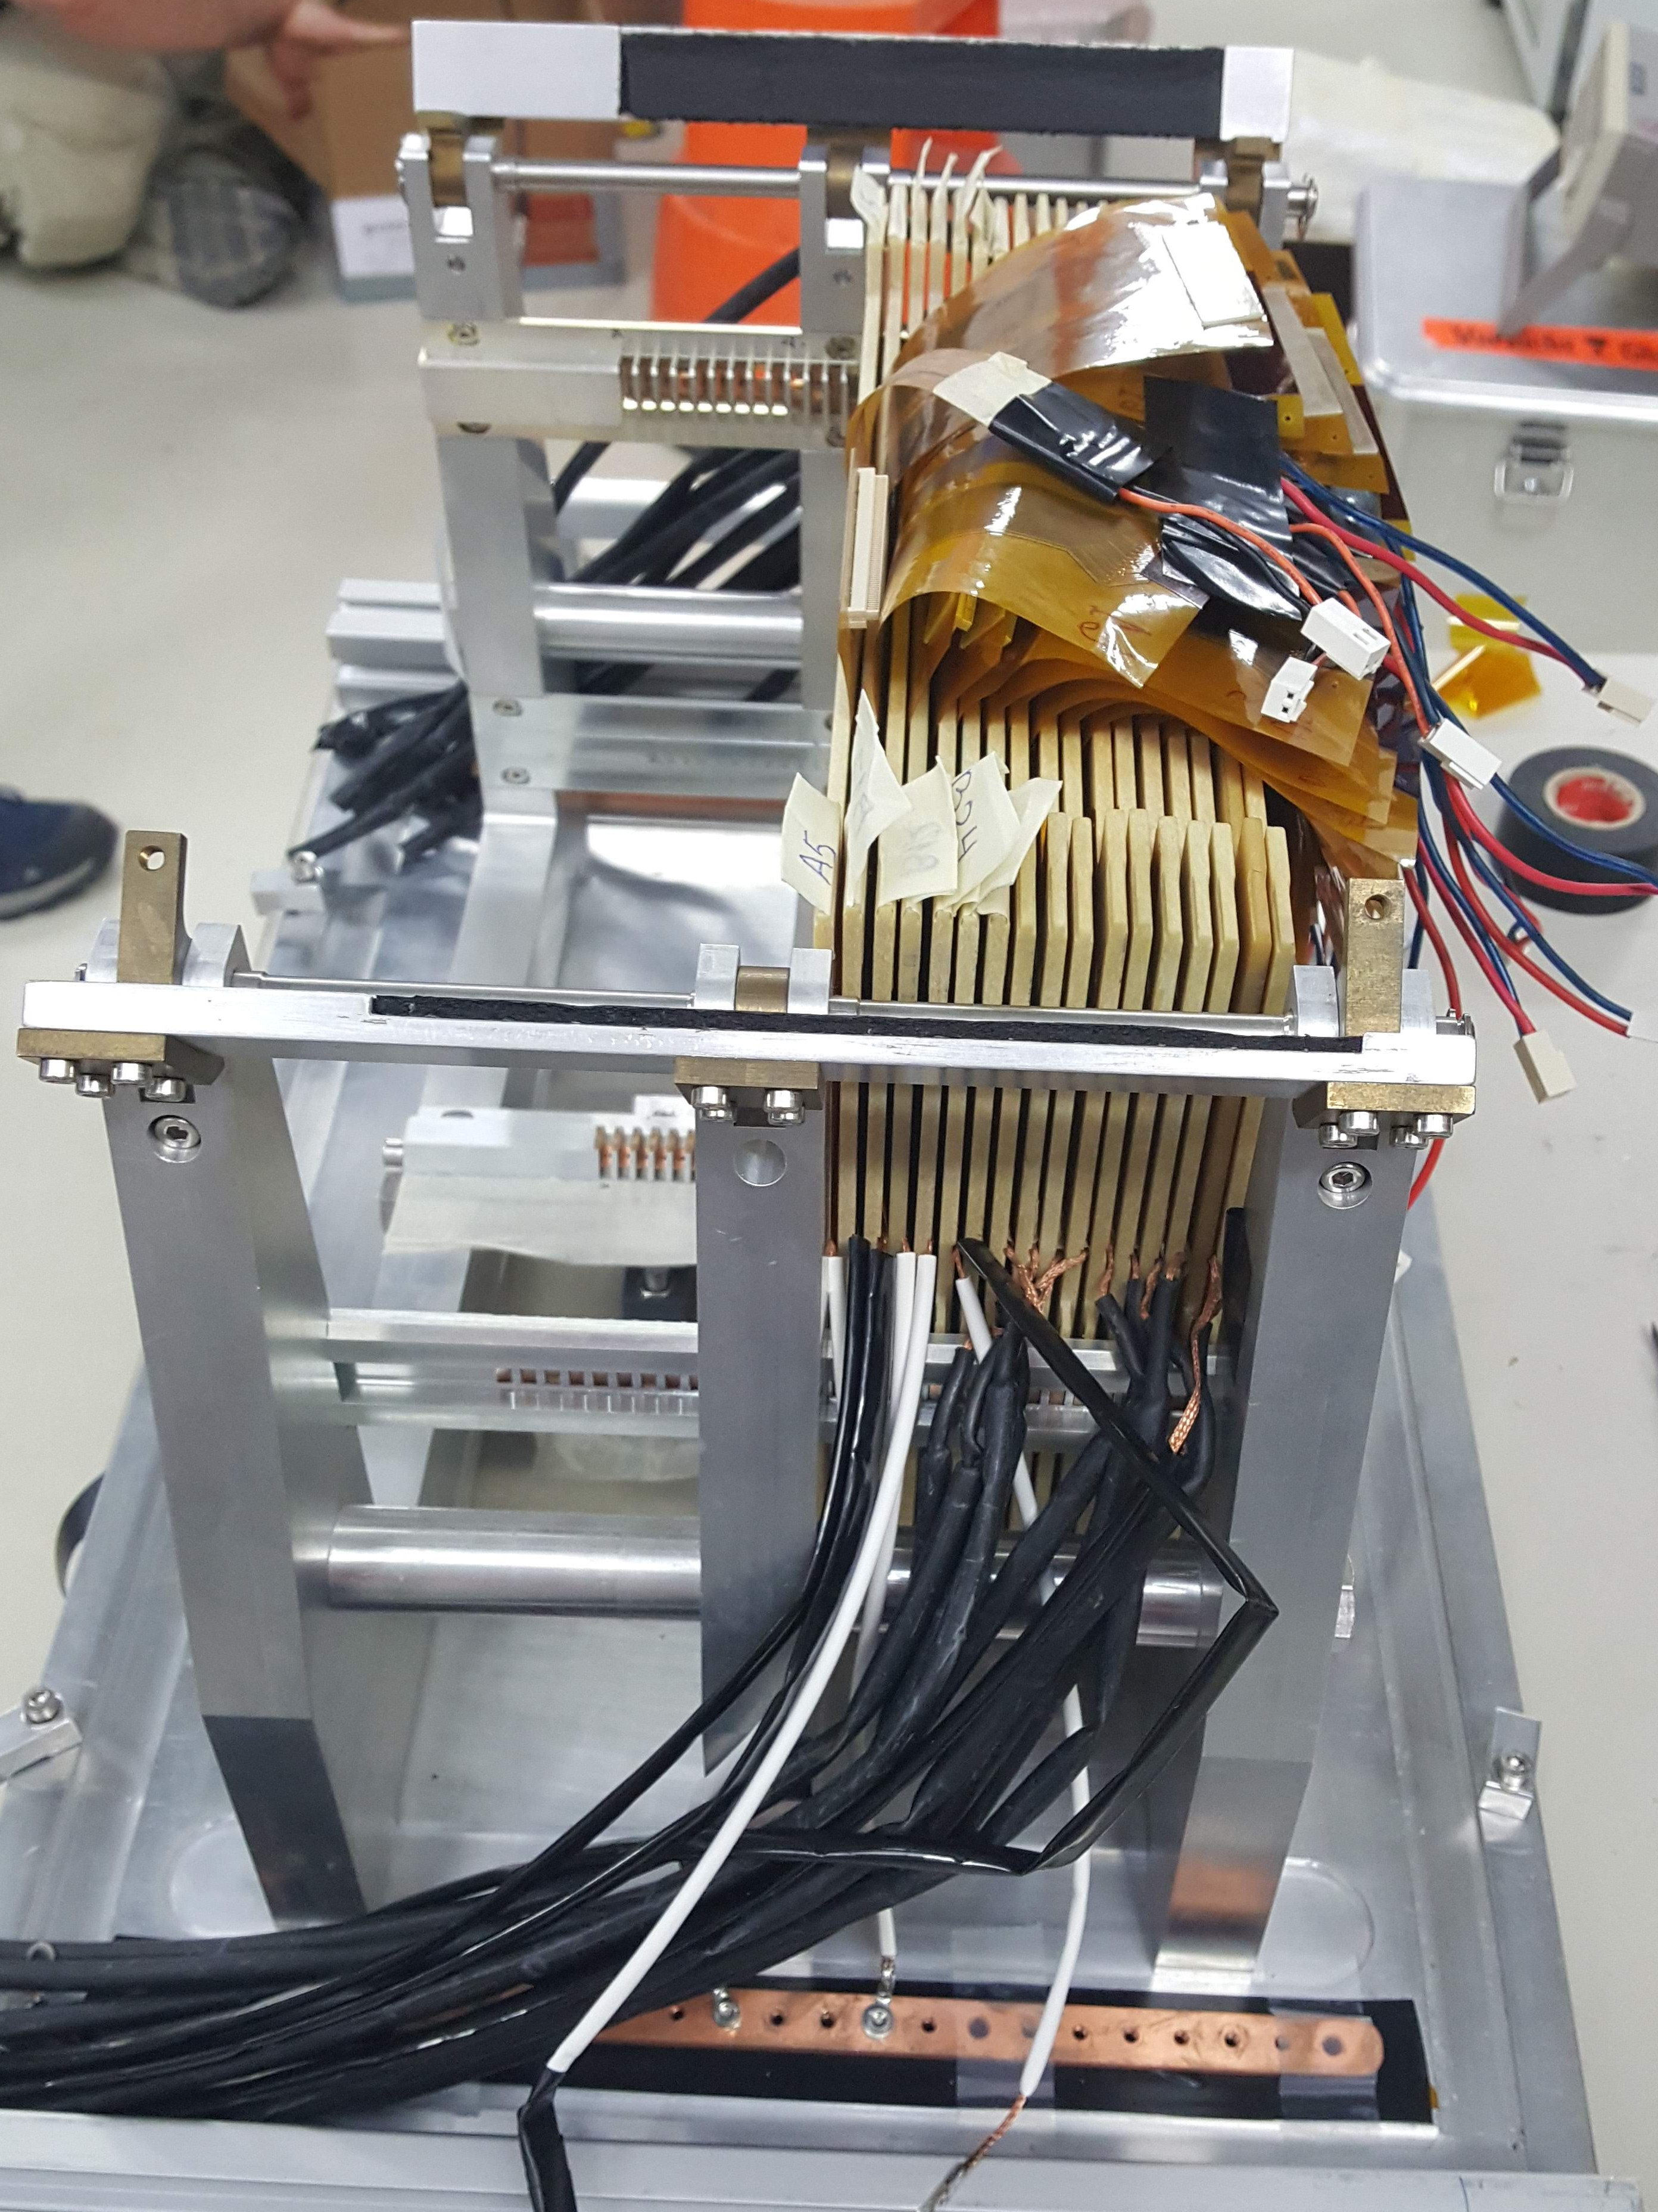

Fig. 11 Assembled calorimeter demonstrator at 2019 beam-test

Validation at beam-tests

The beam-test campaigns were done to study the performance of the compact calorimeter demonstrator and to test the concept of tracking detectors in front of the calorimeter as a tool for electron and photon identification. In order to analyse the electromagnetic shower development, the deposited energy in each sensor plane was used. The measurement results were compared to predictions from GEANT4 Monte Carlo simulations.
The measurement of the effective Moliere radius was carried out for energies between 1 and 5 GeV following the method described in Ref. [10]. The transverse shower profile at 1, 3 and 5 GeV beam energy, as a function of the distance from the core, in units of pad pitch for the data and a fit function, is presented in Fig. 12 [10]. The fitted function reproduces the experimental transverse shower profile with an accuracy better than 5%. The deposited energies are lower at lower beam energies, and the distributions are wider, resulting in a larger value of the effective Moliere radius, an effect which can be explained with an incomplete shower containment due to the limited number of detector planes. The effective Moliere radius is 8.1 ± 0.3 mm for 5 GeV energy electrons, a value well reproduced by the MC simulation 8.4 ± 0.1 mm. All data distributions are well described by the results of simulations.
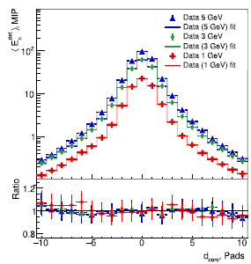

Fig. 12 Average transverse shower profile as a function of d_{core} in units of pads, for different beam energies. The lower portion of the figure displays the ratio between data and fit functions.

FUTURE PLANS / Conclusion / relation to other AIDA-2020 work
The highly compact multi-layer calorimeter demonstrator was built within AIDA-2020 project. During the development beam-tests are performed at the DESY II synchrotron with an electron beam with energies between 1 and 5 GeV at several steps of completion. Using new technology and expertise at each construction step, compact detector planes of 650 µm thickness, together with thin tungsten plates of extremely good flatness, were developed. During the performed beam-tests a temporary readout system, based on APV ASIC was used, since the dedicated FLAME ASIC readout system had been developed in parallel. Measurements of transverse and longitudinal shower shapes were performed and compared to detailed Monte Carlo simulations, and were found to be in good agreement. The effective Moliere radius was determined to be 8.1 ± 0.3 mm. This value is close to the technological limit.
The ultra-low power, dedicated SoC type 32-channel front-end ASIC called FLAME was developed and produced as a core of the compact calorimeter readout system. A compact PCB board holding eight FLAME ASICs was also designed and fabricated. In March 2020 a new beam-test of the full compact calorimeter demonstrator, including the final FLAME based readout system, will be performed..
The demonstrator will be used in future for very detailed measurements of parameters relevant for the measurement of the luminosity, but also of interest for precision electromagnetic calorimetry. Also improvements are considered, e.g. a miniaturisation of the readout PCB to match requirements from the integration in a future experiment, or edgeless sensors to improve the homogeneity of the response.
As a spin-off, part of the FLAME ASIC is currently used for the upgrade of the high granularity electromagnetic calorimeter and the timing detector of the CMS experiment.

References

[1] H. Abramowicz et al., Forward Instrumentation for ILC Detectors, JINST 5 (2010) P12002
DOI: 10.1088/1748-0221/5/12/P12002.
[2] T. Behnke et al.,The International Linear Collider. Technical Design Report, Volume 4: Detectors, 2013. arXiv:1306.6329[physics.ins-det].
[3] A. Abusleme, et al., Detector Technologies for CLIC, CERN Yellow Report CERN-2019-001, http://arxiv.org/abs/arXiv:1905.02520.
[4] H. Abramowicz et al., Performance of fully instrumented detector planes of the forward calorimeter of a Linear Collider detector, JINST 10 (2015) no.05, P05009
DOI: 10.1088/1748-0221/10/05/P05009.
[5] H. Abramowicz et al., Measurement of shower development and its Moliere radius with a four-plane LumiCal test set-up, The European Physical Journal C78 (2018), 135,
DOI: 10.1140/epjc/s10052-018-5611-9.
[6] M. Idzik, et al., FLAME – readout ASIC for luminosity calorimeter at future linear collider, Topical Workshop on Electronics dor Particle Physics, TWEPP 2018, 17-21 September 2018, KU Leuven, Antwerpen, Belgium, https://indico.cern.ch/event/697988/contributions/3055910/attachments/1718342/2772974/idzik_TWEPP2018_FLAME.pdf.
[7] J. Moron, et al., Development of ultra-low power, rad-hard SAR ADCs in 130 nm CMOS technologies, Topical Workshop on Electronics dor Particle Physics, TWEPP 2018, 17-21 September 2018, KU Leuven, Antwerpen, Belgium, https://indico.cern.ch/event/697988/contributions/3055906/attachments/1718216/2772757/moron_Twepp_ADC_2018_09.pdf.
[8] M. Idzik, Design and test of ASICs and readout board prototype for the test infrastructure, AIDA-2020 Milestone Report AIDA-2020-MS57 (2017).
[9] M.J. French, et al., Design and results from the APV25, a deep sub-micron CMOS front-end chip for the CMS tracker, Nucl. Instr. Methods A 466, 359 (2001).
[10] H. Abramowicz, et al., Performance and Molière radius measurements using a compact prototype of LumiCal in an electron test beam, The European Physical Journal C 79 (2019) 579,
DOI: 10.1140/epjc/s10052-019-7077-9.

Annex: Glossary

Acronym | Definition
ASIC | Application Specific Integrated Circuit
LumiCal | Luminosity Calorimeter
BeamCal | Beam Monitor Caloruimeter
PCB | Printed Circuit Board

